Sturdy 0.5 hp electric wheel, with lotus style wheelhead and many bats. £2000 or near offer…
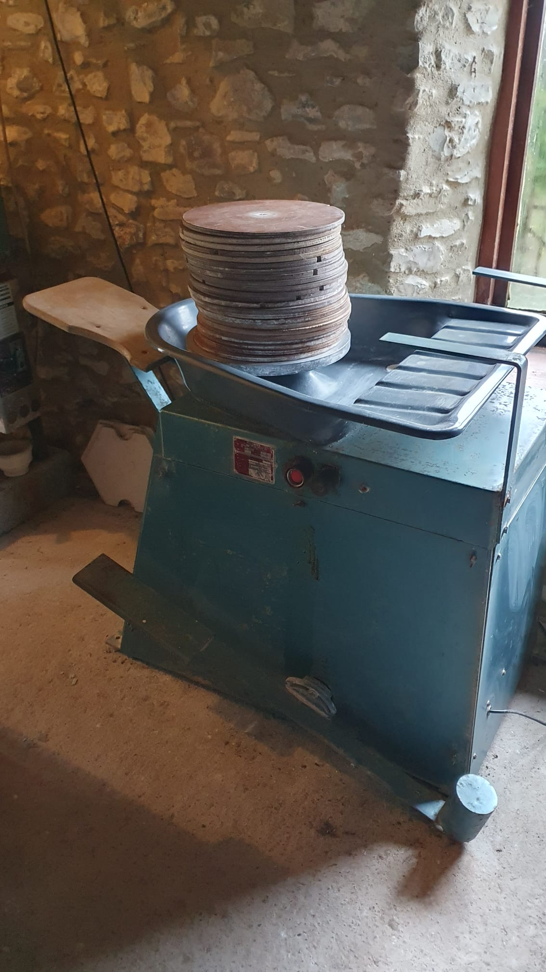 | 