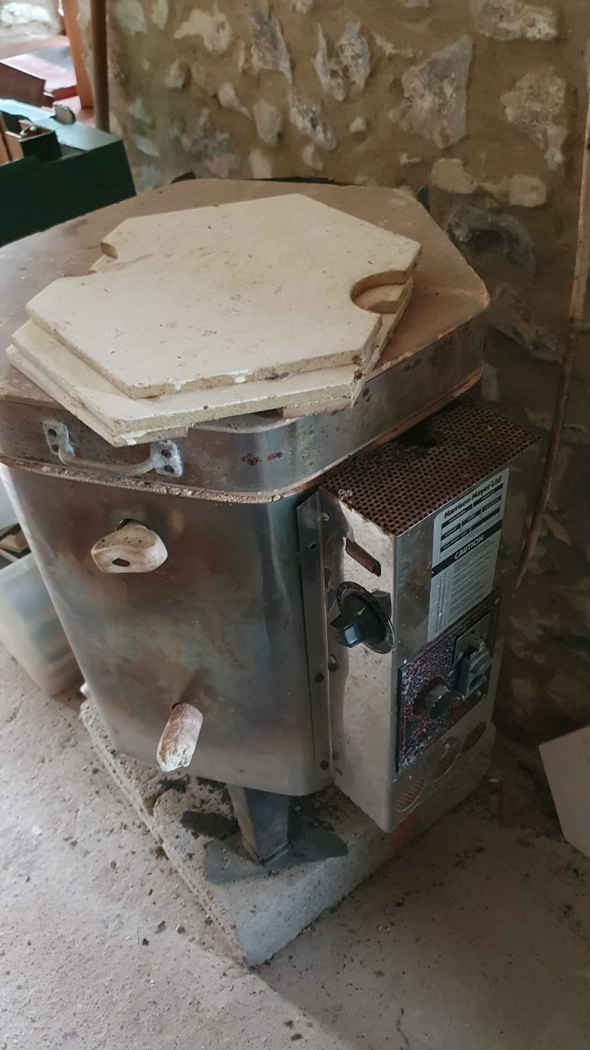  Kiln doesn’t work either sell for spares or Raku kiln 49cm x 49cm £100 ono | 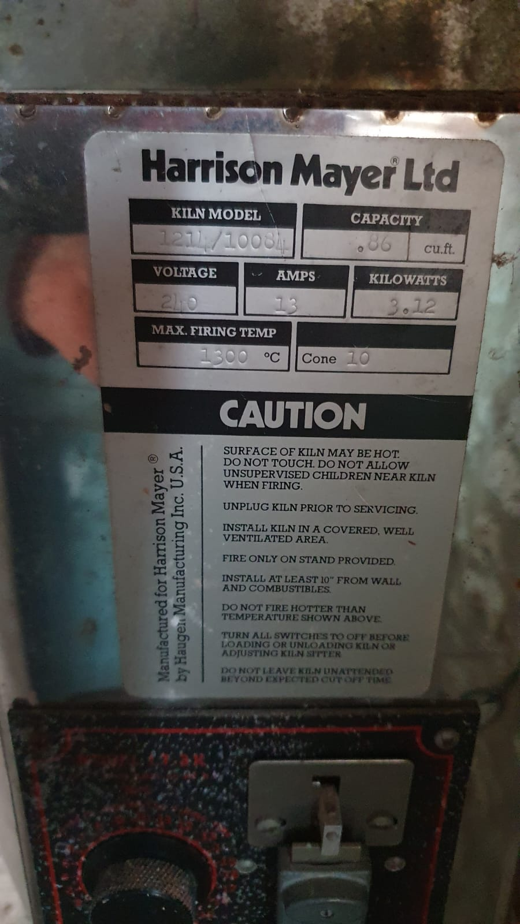
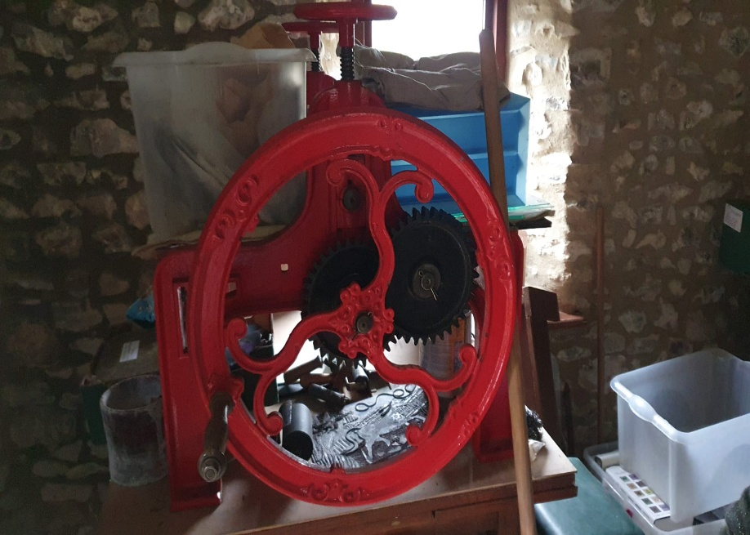

Also a substantial weight flat-bed etching Press available

