Leach design kick wheel, 99 cm tall, 98cm width from back to front, width of basin 86.5 cm. Lightly used and in good condition as below £1500 ono
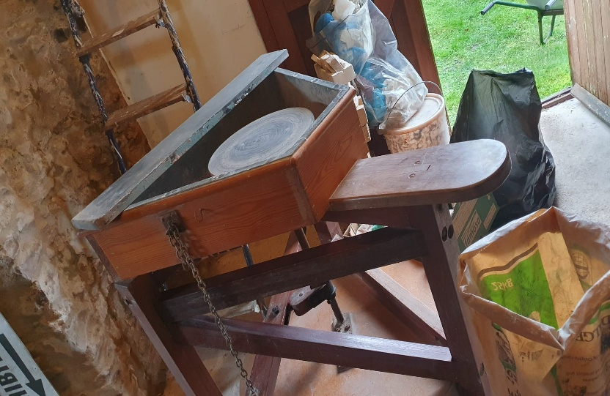 |  | 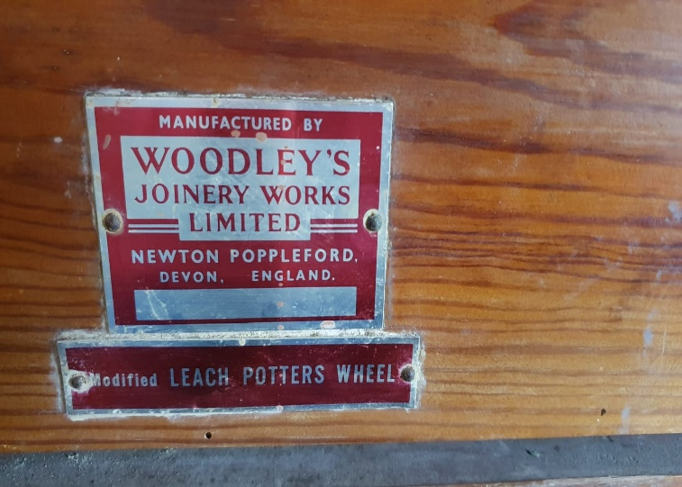
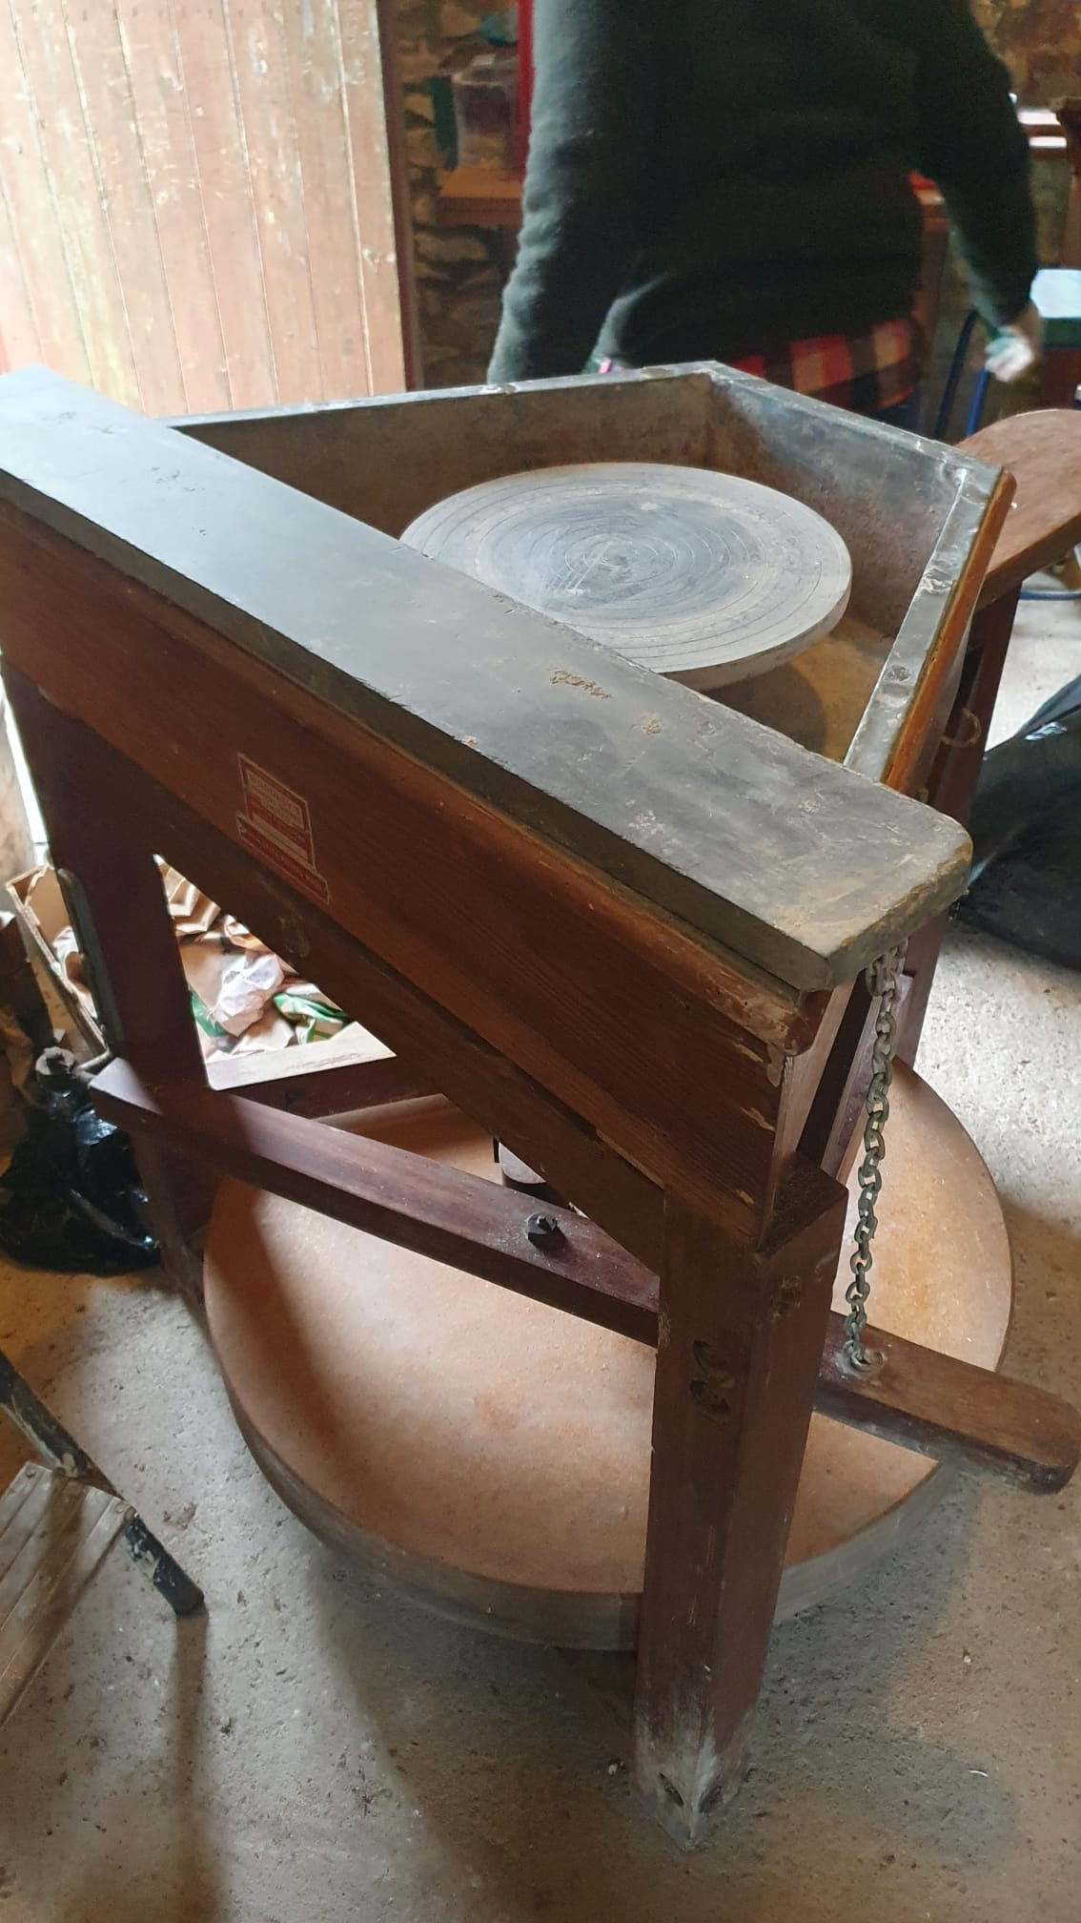  Leach wheel | 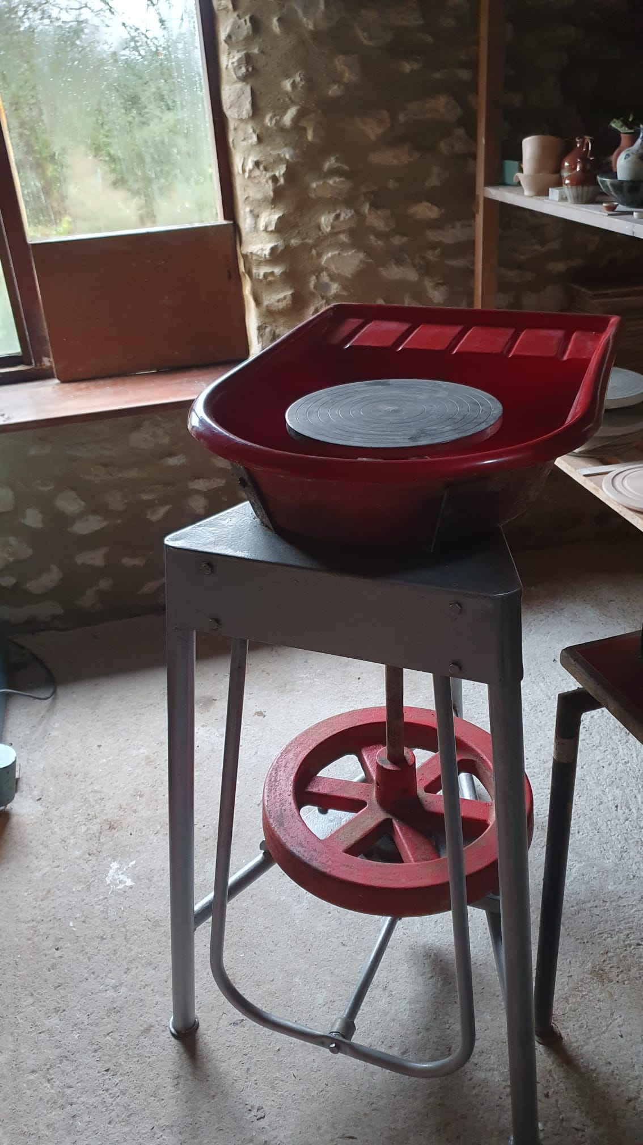  Manual red pottery kick wheel 91x47 runs true £300 ono. spare wheel heads 25.5 cm circumference £100 each ono see picture below

