Large kiln with controller: Internal 47cm high x 46cm wide - External 79cms wide, 83 cms deep, from floor to top 140cms. 9.62 kw/1300C - see picture below £4000 ono
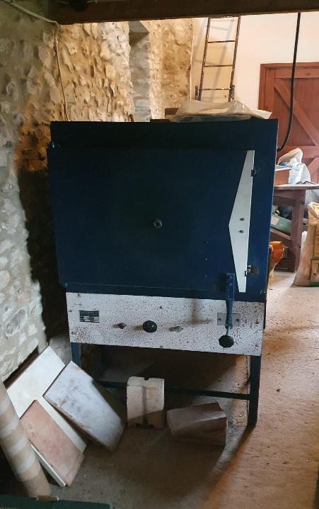 | 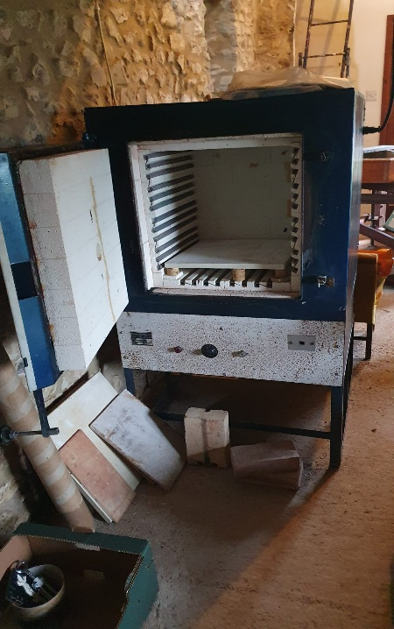
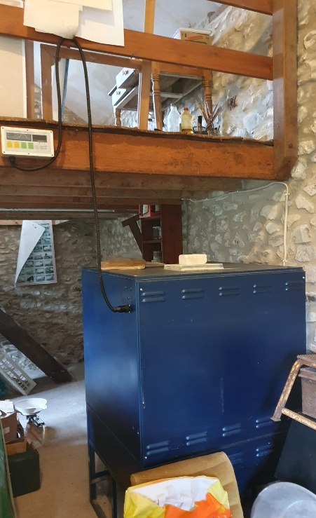 | 